Deep Learning Experiment 4

Aim :-

To display first 9 images of four datasets CIFAR10, CIFAR100, MNIST, Fashion MNIST **Observations** :-

1. CIFAR10

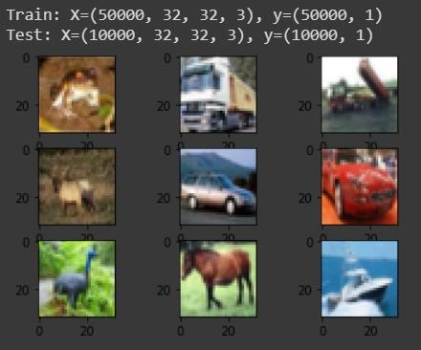

2.CIFAR100

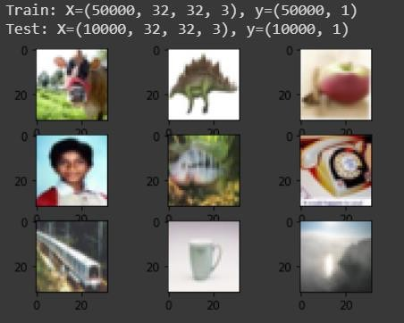

3.MNIST

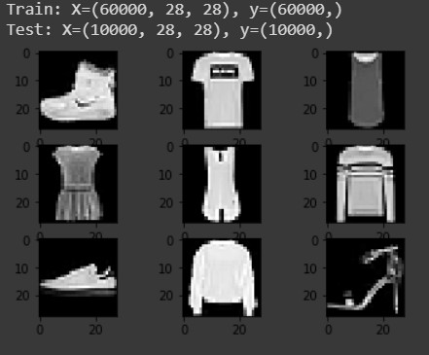

4) Fashion MNIST

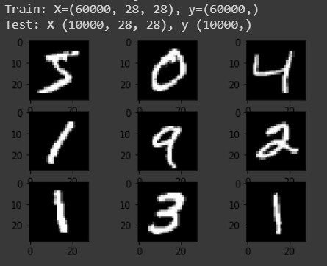

The link for the google collab sheet on which the code to display these 4 images was run -

<https://colab.research.google.com/drive/1HLdE6L12_wLJRgC_GQ2jmr0uC7-pxeWh#forceEdit=true&sandboxMode=true&scrollTo=fmr8UMWN3dfS>

**Conclusion :-**

We successfully displayed images of this 4 datasets.